**Image segmentation :**

**Treshold techniques :**

* 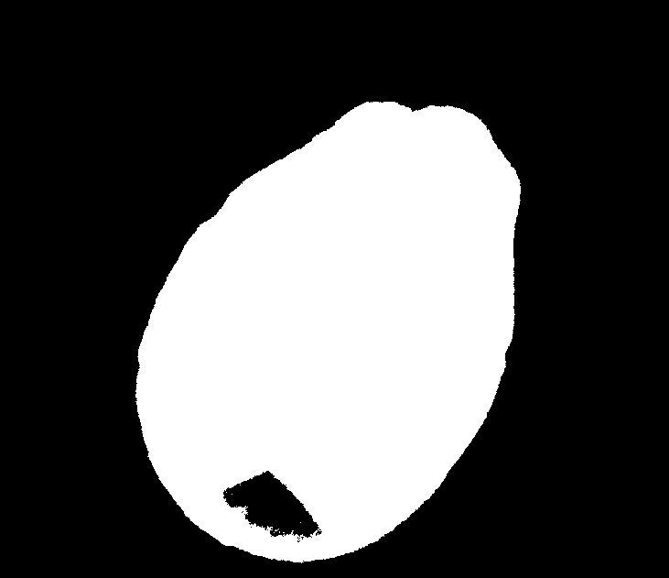**General treshold :**
* **adaptative tresholding**
  + ([**ADAPTIVE_THRESH_GAUSSIAN_C**](https://docs.opencv.org/4.x/d7/d1b/group__imgproc__misc.html#ggaa42a3e6ef26247da787bf34030ed772caf262a01e7a3f112bbab4e8d8e28182dd)) The threshold value is a gaussian-weighted sum of the neighbourhood values minus the constant **C**.

**block_size = 11**

**constant = 2**

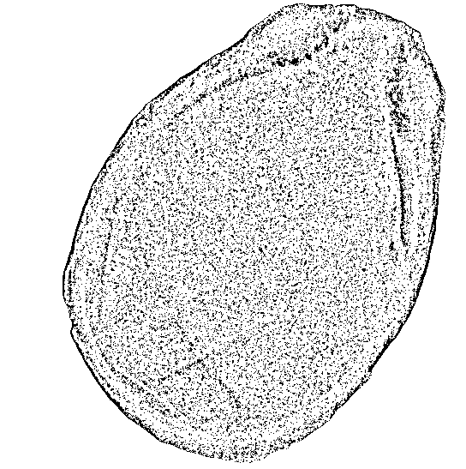

**block_size = 11**

**constant = 0**

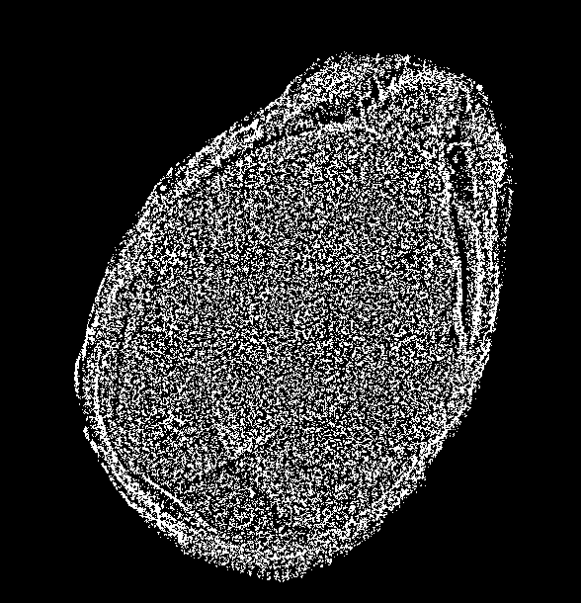

**block_size = 13**

**constant = 2**

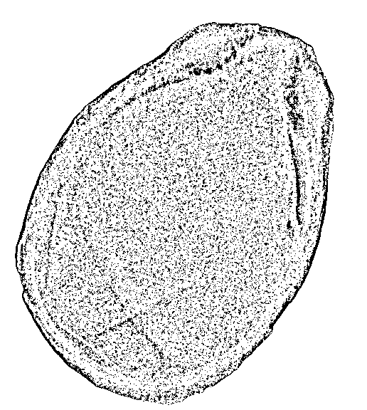

* [**ADAPTIVE_THRESH_MEAN_C**](https://docs.opencv.org/4.x/d7/d1b/group__imgproc__misc.html#ggaa42a3e6ef26247da787bf34030ed772cad0c5199ae8637a6b195062fea4789fa9): The threshold value is the mean of the neighbourhood area minus the constant **C**.

block_size = 11

constant = 2

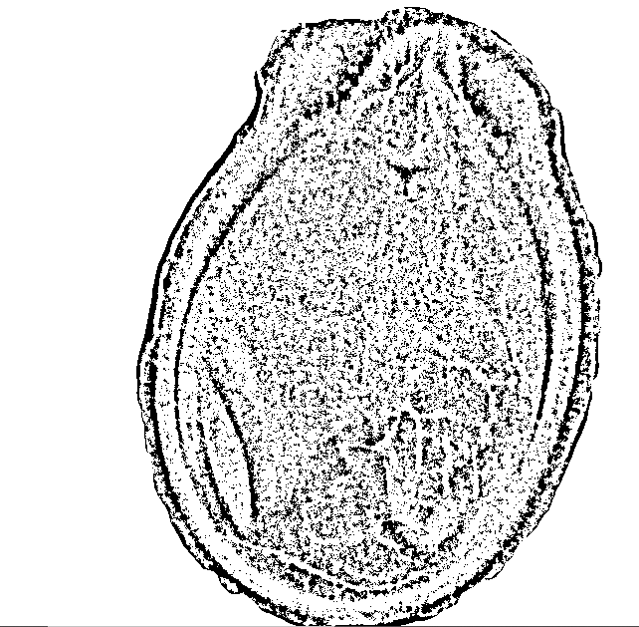

block_size = 11

constant = 0 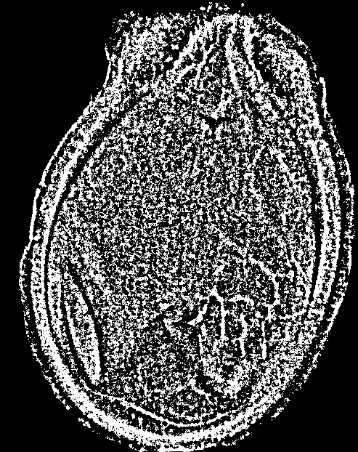

block_size = 13

constant = 2

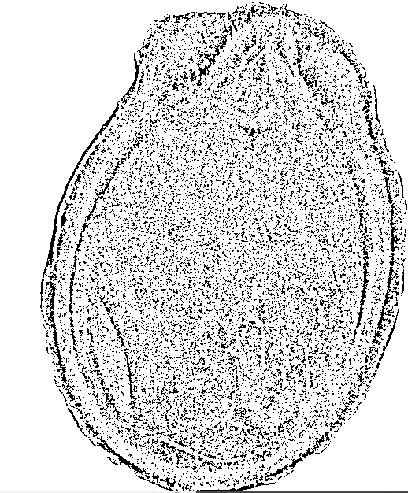

* **Otsu threshold :**

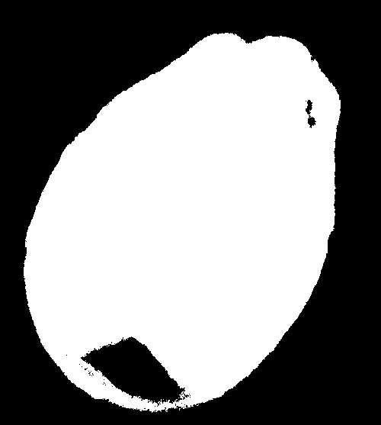

* Region growing :

Threshold=100

seed_point = (600, 600)

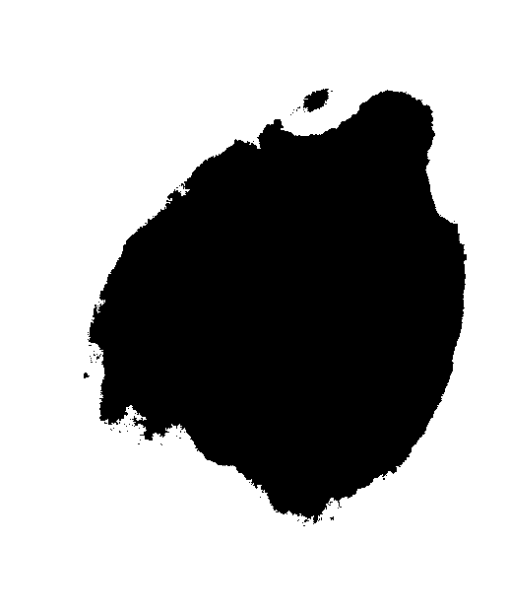

Threshold=300

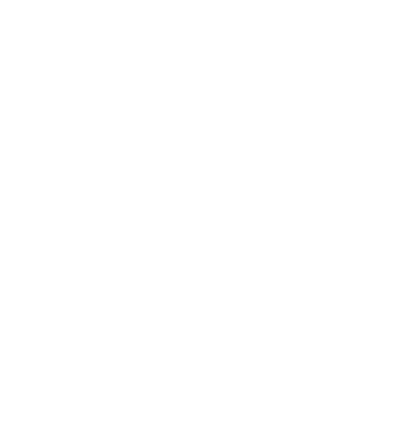 seed_point = (600, 600)

Threshold=100

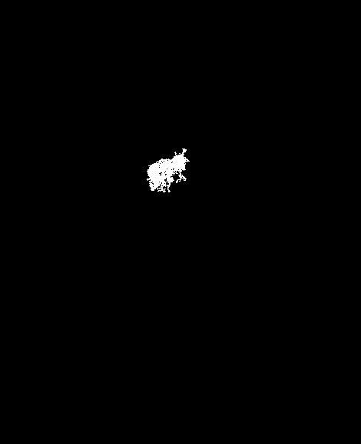seed_point = (300, 300)

* Watershed algorithm :

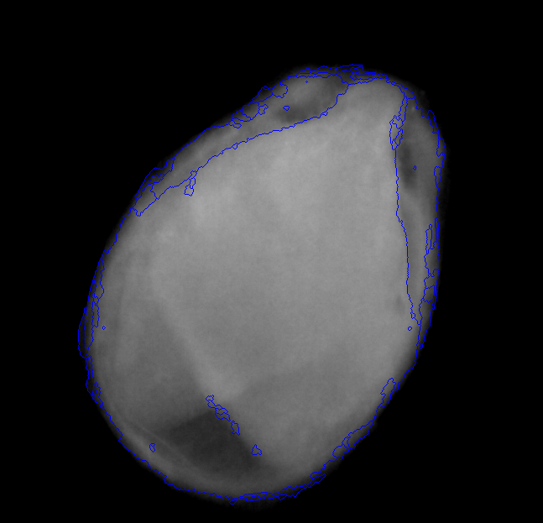

* fuzzy c mean ( still no result)

**feature extraction :**

* PCA :

You can check the code in the last cell of watershedvalid.ipynb

To be implemented :

* **Linear Discriminant Analysis (LDA)**

## Locally Linear Embedding (LLE)

## Independent Component Analysis (ICA)